Claim Quest Instructions
Thursday, February 17, 2022
8:54 AM
Link to Claim Quest: ISO ClaimSearch
  - 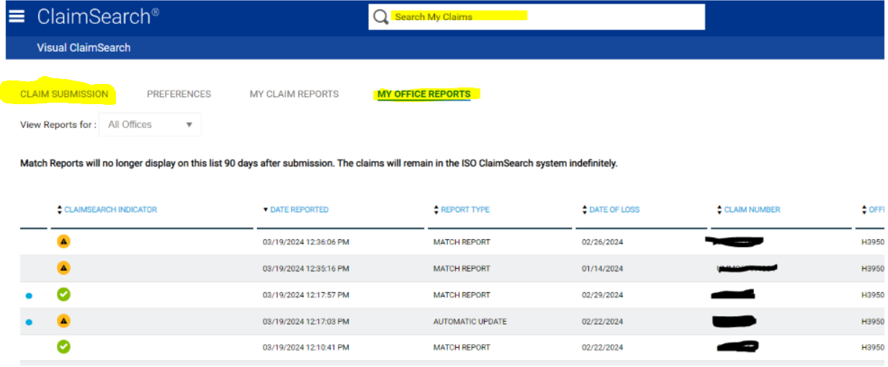
  - Total patient balance must be $500+.
  - Before creating a new Claim Quest claim search to make sure there hasn't already been one created.
    - Make sure you are searching under "my office reports"
      - This will allow you to see ALL claims created by anyone from our office, not just the claims you have created.
    - Use the following items to search by
      - CUBS#
      - DRL#/MRN#
      - CDN#/ACCOUNT#
  - If the claim has already been submitted review the claim and determine if there is any new information that has been returned.
    - If the claim has not been previously submitted move to the next step.
      - Click on Claim Submission as highlighted in previous screen shot
        - You will be taken here:

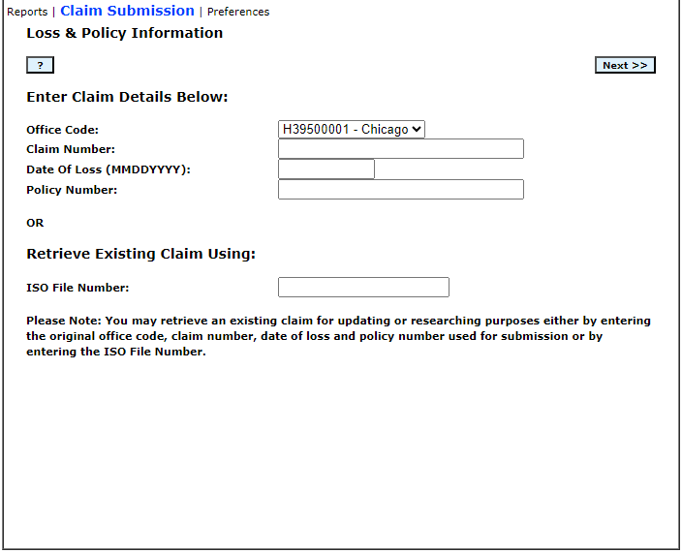
  - Enter the following data:
    - Office code – Will always be H39500001 – Harris and Harris
    - Claim number – Your provider prefix + the DRL#/MRN#
      - Provider Prefix:
        - Advocate: ADV
          - Advocate: Drop the 00000 prefix and only use the remaining 7 digits
        - UMMC: UMMC
        - IU: IU
    - Date of Loss – or Patient admit date if you do not have the DOL
    - Policy Number – Your provider prefix + the DRL#/MRN#
      - 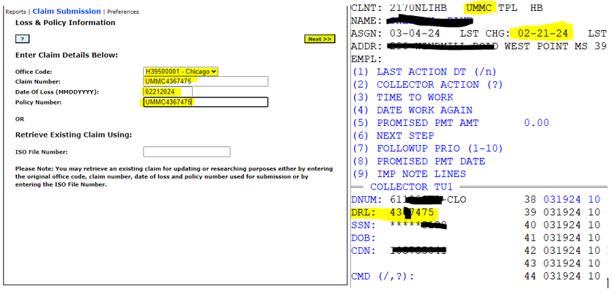
  - Click Next

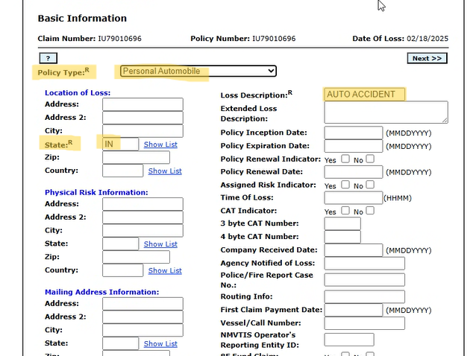

  - All fields highlighted in yellow are required fields and must be populated.
    - Policy Type – Will always be Personal Automobile
    - State – If you know the state that the accident occurred use that state. If not use the state of residence for the patient
    - Loss Description – Use Auto Accident or Work Comp Accident
  - Click Next

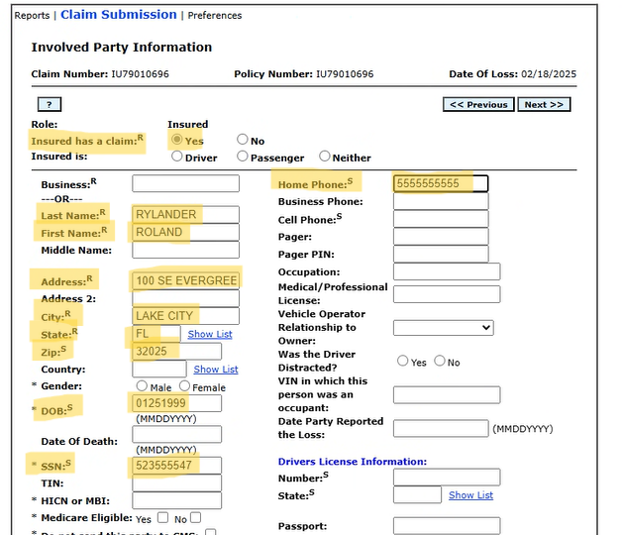

  - All fields highlighted in Yellow are required
    - Role – Will always be Both Claimant and Insured
    - Last Name and First Name – Should be the name of the patient
    - Address, City, State, and Zip – Should be the patients home address
  - Click Next

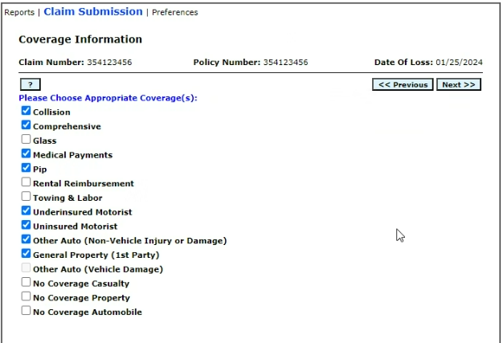

  - Choose Collision, Comprehensive, Medical payments, PIP, Underinsured Motorist, Uninsured Motorist, Other Auto, and General Property (1st Party)
  - Click Next

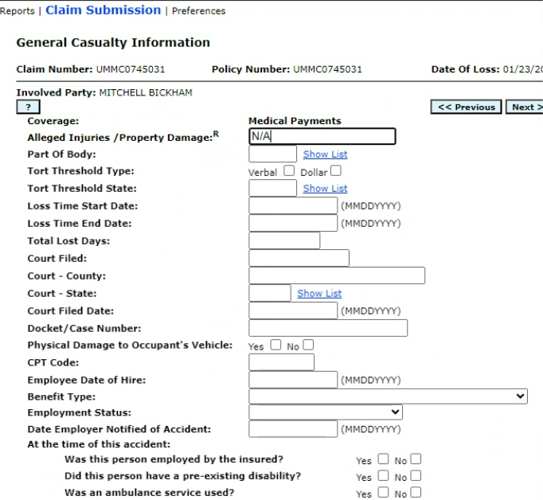

  - Enter NA in the Alleged Injuries/Property Damage field
  - Click Next

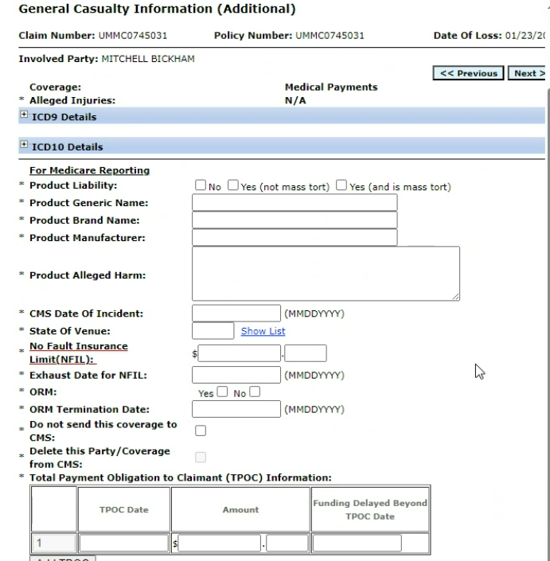
1. There is no info to populate on this screen. Click Next

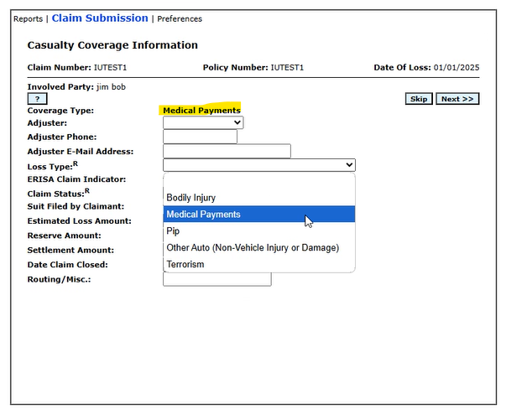

  - Loss Type – Should always match coverage type
    - Medpay = Medpay
    - PIP = PIP
    - Underinsured, Uninsured, = Bodily Injury
    - Other = Other
  - Claim Status – Should always be open
  - Click Next

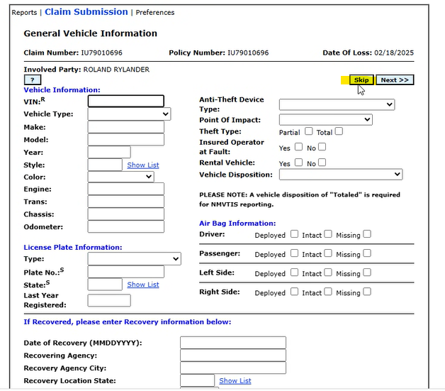

  - Click Skip
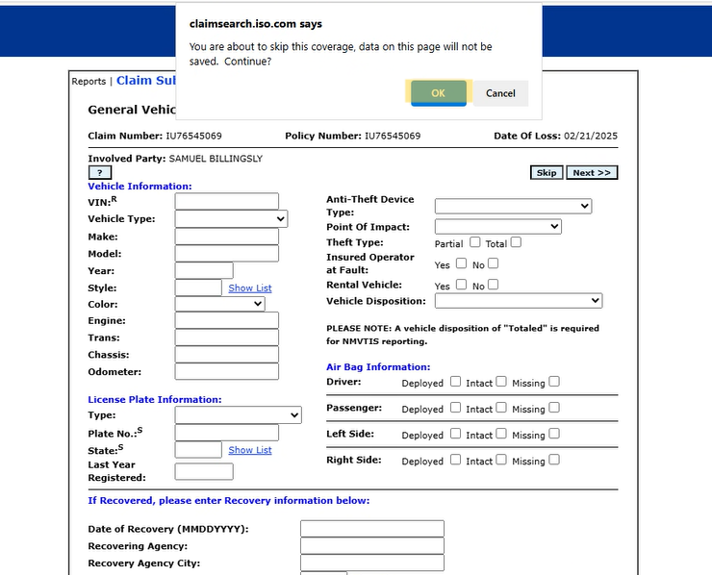
  - Click Okay
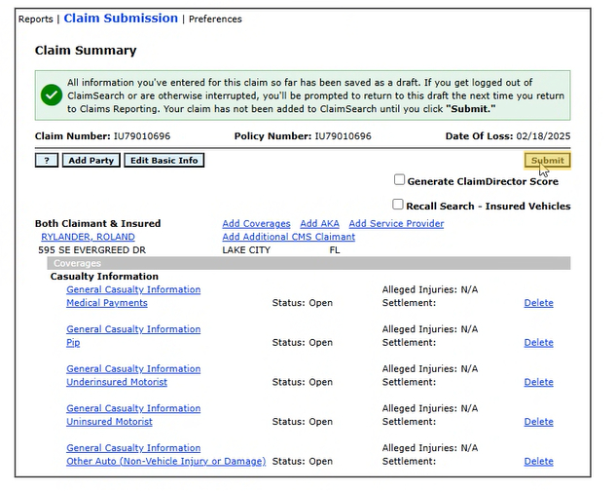
  - Review to make sure everything on this screen is correct.
  - If everything looks correct click submit
  - Once you click submit you will be taken back to your ISO Claims search results screen
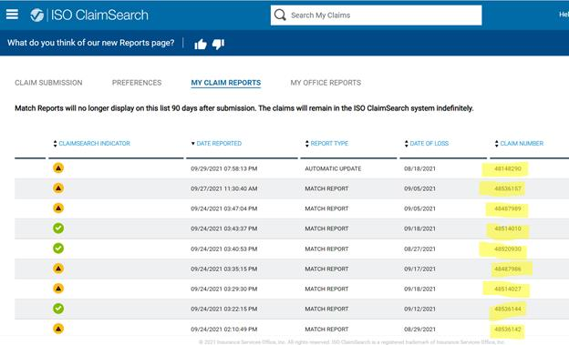

  - Look for the claim number that matches the claim number that you used for the claim you just entered. (Remember this is Your provider prefix + the DRL#/MRN#)
  - Once you locate your claim click on it to review the results.
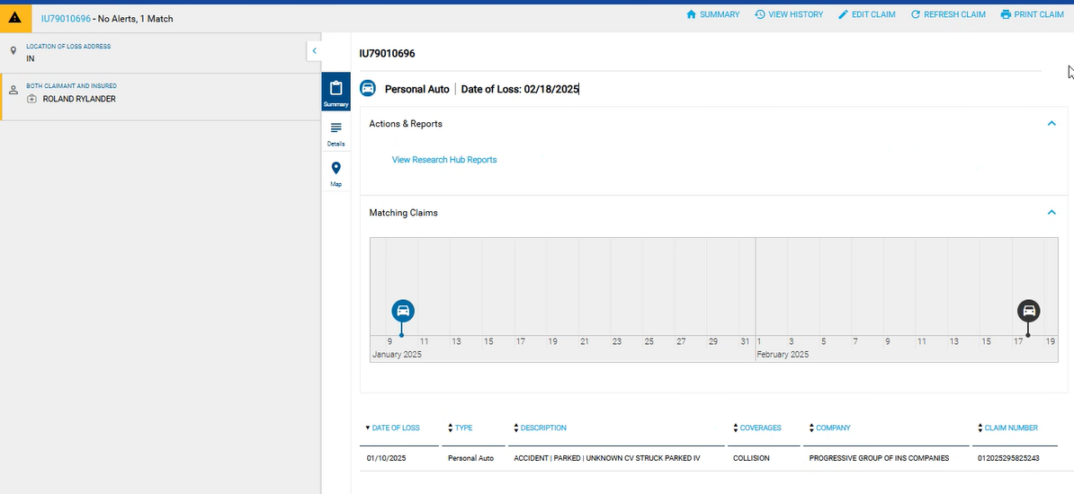

  - This is what the results screen will look like
  - Click on any of the results to review the details of that result
    - The details should contain all information you need to be able to submit the bill for that claim. However! We must call and verify all info including billing address and fax#.
    - If the DOA/DOI that you are searching for is not listed, but a previous claim for a different DOI/DOA is listed with:
      - MP/1st party insurance (Patient will be listed as the insured on the policy.)
        - Admin must follow up with insurance listed.
          - If Admin is unable to speak to a Rep with the auto insurance to confirm new claim, ISO lists the Policy number under the “Personal Auto” section in all the claims, the claim should be billed using the Policy number. (If no claims filed for the current DOA, the 1st party insurance could reach out to their insured to inquire, or they may start opening a claim)
      - BI/TPL insurance (Patient will be listed as the claimant….
        - We will be calling to see if they have our patient's auto carrier information on file from that DOI. If so, we would call that insurance lead to see if there is a new claim on file for this new DOI.
  - If there are no results listed that means ISO did not find any matches for the data you put in. In this instance we need to continue to make attempts to contact the patient for information.

Additional Notes:
  - Claim Quest and Progressive:
    - Remove the first 4 digits from the Claim# listed.
      - Progressive claim# s are 9 digits long and begin with the 2 digit year
        - Example: 012024517577
  - Account must have a minimum balance of $500 to be submitted through ISO
  - Iso will send us automatic updates if a claim is open for a patient after we submit the information to ISO.
  - ISO is to only be used for accounts placed with Harris and Harris.
  - Do not use the word ISO in your notes in CUBS. Instead use the words “Claim Quest” or "CQ"

- INITIAL SET UP
  - Po
  - Click ADD

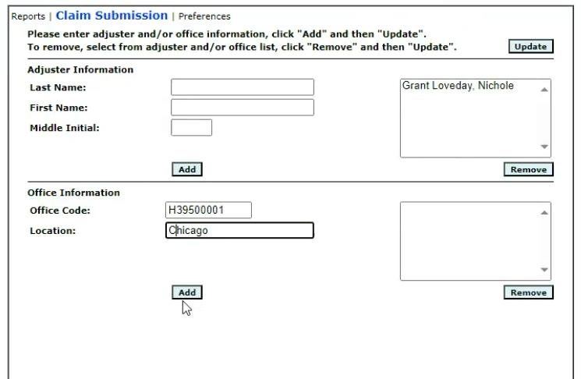

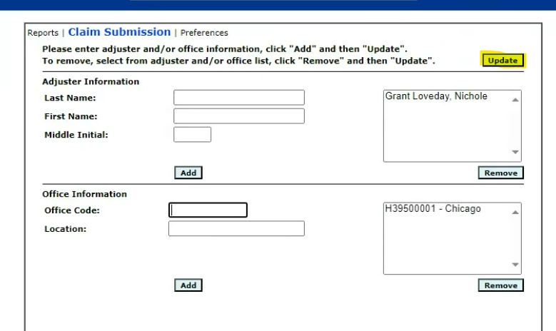

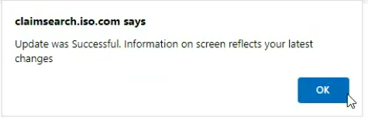
- Click "OK"

